**5. PARAMETERS CALCULATION OF A CURRENT SERIES FEEDBACK AMPLIFIER**

**AIM:** To calculate the input impedance, output impedance and voltage gain of current series feedback amplifier with and without feedback.

**APPARATUS** :

Power supply 0-30V 1No.

CRO 20MHz 1No.

Signal generator 1-1MHz 1 No

Resistors 1kΩ, 4.7k, 8.2k 1 No

2.2k,33k,10K 1 No

Capacitors 10µF 3 No

Transistors BC107 1 No

Bread board

CRO Probes

**THEORY:**

An amplifiers impedance value is particularly important for analysis especially when cascading individual amplifier stages together one after another to minimize distortion of the signal.

The input impedance of an amplifier is the input impedance “seen” by the source driving the input of the amplifier. If it is too low, it can have an adverse loading effect on the previous stage and possibly affecting the frequency response and output signal level of that stage. But in most applications, common emitter and common collector amplifier circuits generally have high input impedances.

Output and Input Impedance Model

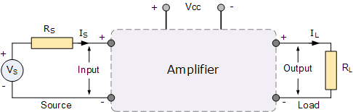

Where, VS is the signal voltage, RS is the internal resistance of the signal source, and RLis the load resistance connected across the output. We can expand this idea further by looking at how the amplifier is connected to the source and load.

When an amplifier is connected to a signal source, the source “sees” the input impedance, Zin of the amplifier as a load. Likewise, the input voltage, Vin is what the amplifier sees across the input impedance, Zin. Then the amplifiers input can be modelled as a simple voltage divider circuit as shown.

Amplifier Input Circuit Model

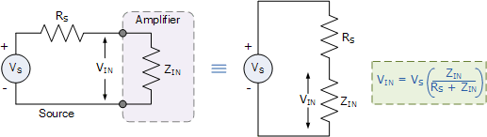

The same idea applies for the output impedance of the amplifier. When a load resistance, RL is connected to the output of the amplifier, the amplifier becomes the source feeding the load. Therefore, the output voltage and impedance automatically becomes the source voltage and source impedance for the load as shown.

Amplifier Output Circuit Model

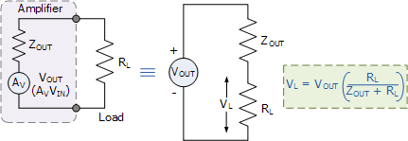

Then we can see that the input and output characteristics of an amplifier can both be modelled as a simple voltage divider network. The amplifier itself can be connected inCommon Emitter (emitter grounded), Common Collector (emitter follower) or inCommon Base configurations. In this tutorial we will look at the bipolar transistor connected in a common emitter configuration seen previously.

**CIRCUIT DIAGRAM**S:-

Vs

FREQ = 1k

VAMPL = 20mV

10

K

Vo (CRO)

K

2.2

Ouf

1

E

K

1

BC107A

uf

10

C

K

4.7

Vcc = 10V

33

K

B

8.2

K

# CURRENT SERIES AMPLIFIER WITH FEEDBACK

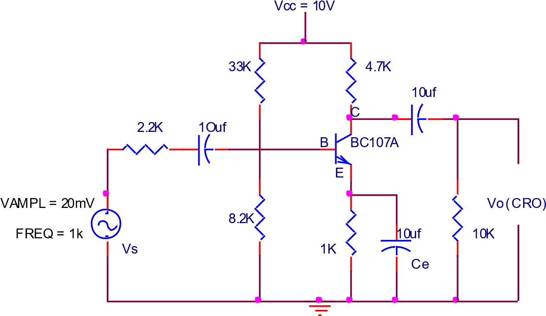

## CURRENT SERIES AMPLIFIER WITHOUT FEEDBACK

**Theoretical Calculations:**

**Calculation of hie= hfex re**

hfe= using multimeter calculate hfe value for the given transistor re= 26mV/IE

IE=VE/RE(calculate drop across RE using multimeter for DC bias circuit) **Input impedancae without Feedback:**



**Output impedancae without Feedback:**



**Voltage gain without feedback:**



**Input impedancae with Feedback:**



**Output impedancae with Feedback:**



**Voltage gain with feedback:**



**Calculate:**

|  |  |
| --- | --- |
| **Without feedback:** | **With feedback :** |
| = **126.5** | = 126.5 |
| = **-426.93** | = -791.61 |
| = **4.766** | = 4.766 |

**PROCEDURE:**

1. Connections are made as per the circuit diagram. Without input source, Ce and load i.e in DC bias
2. A 10V DC supply is given to the circuit for biasing
3. Calculate emitter voltage across Re and find emitter current Ie
4. Circuit is connected as per circuit diagram without feedback i.e., without Ce.
5. A certain amplitude of input signal (say 20mV) is kept constant using the function at a constant frequency of 1KHz
6. Note down the VIN ,VL  , VNL using multimeter
7. Now the Circuit is connected as per circuit diagram with feedback i.e keeping Ce
8. Note down the VIN ,VL  , VNL using multimeter
9. Calculate input impedance ZIN ,output impedance ZO ,and voltage gain AV and compare with theoretical values.

**OBSERVATION**

CIRCUIT DIAGRAM WITH FEEDBACK

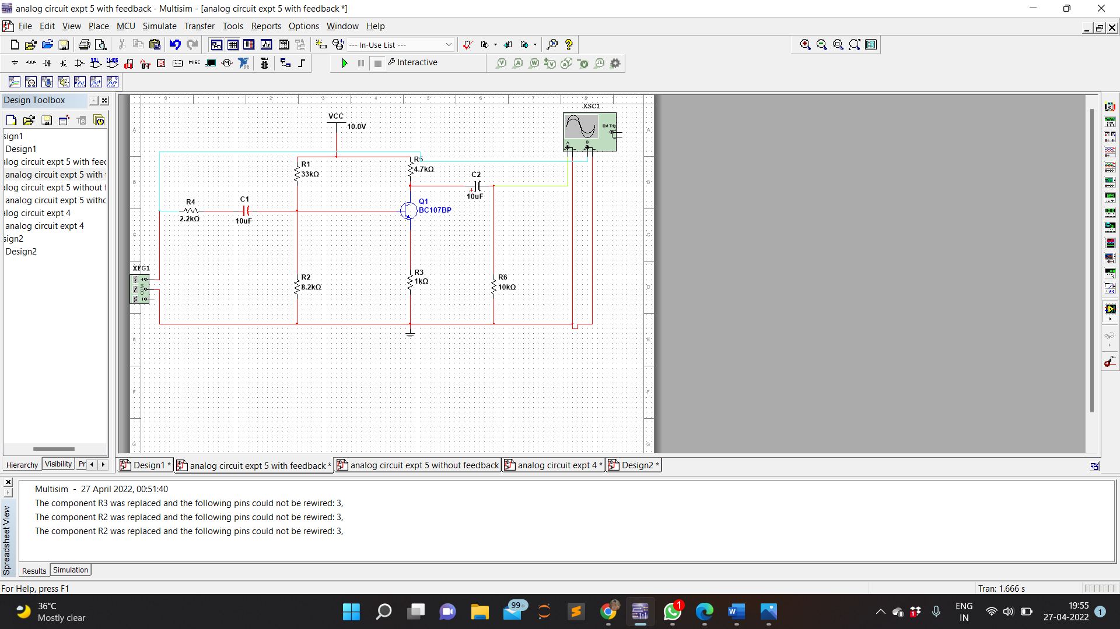

WAVEFORM IN CASE OF WITH FEEDBACK

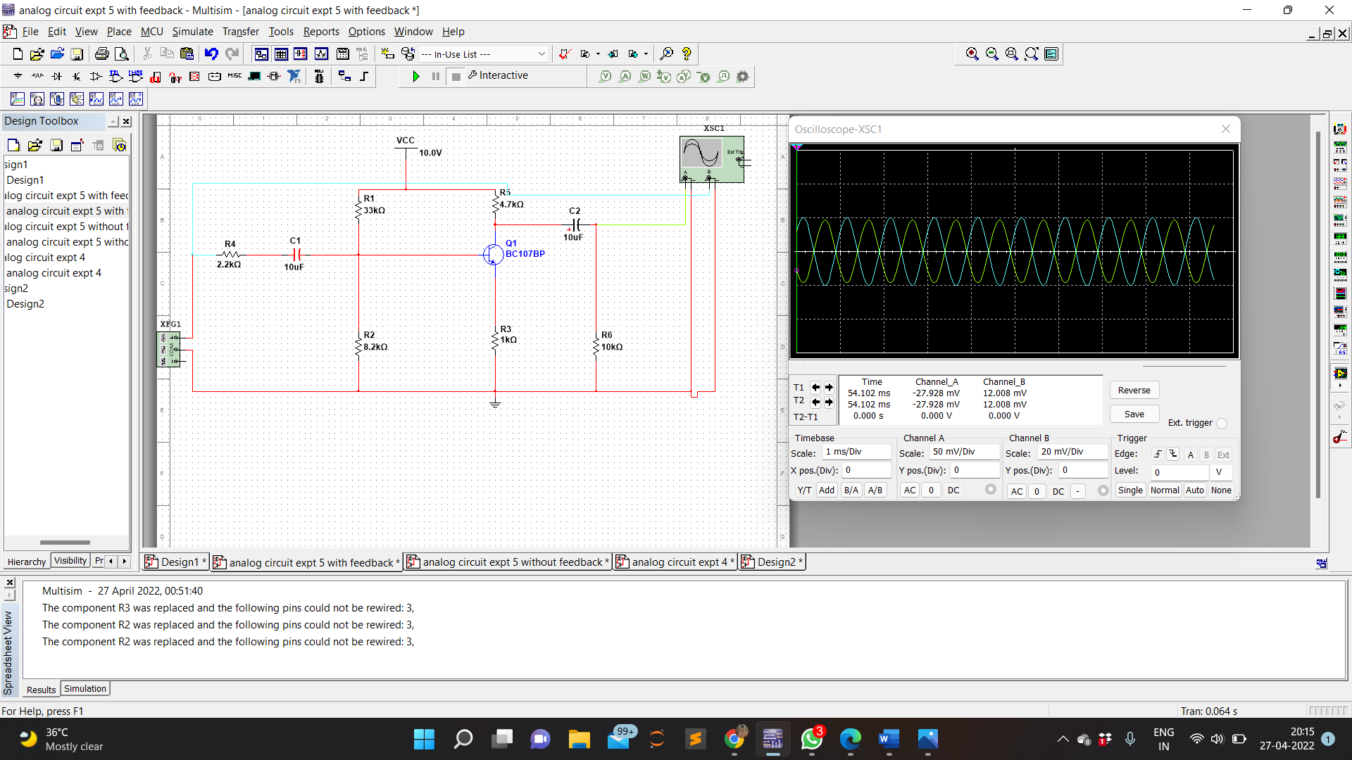

CIRCUIT DIAGRAM WITHOUT FEEDBACK

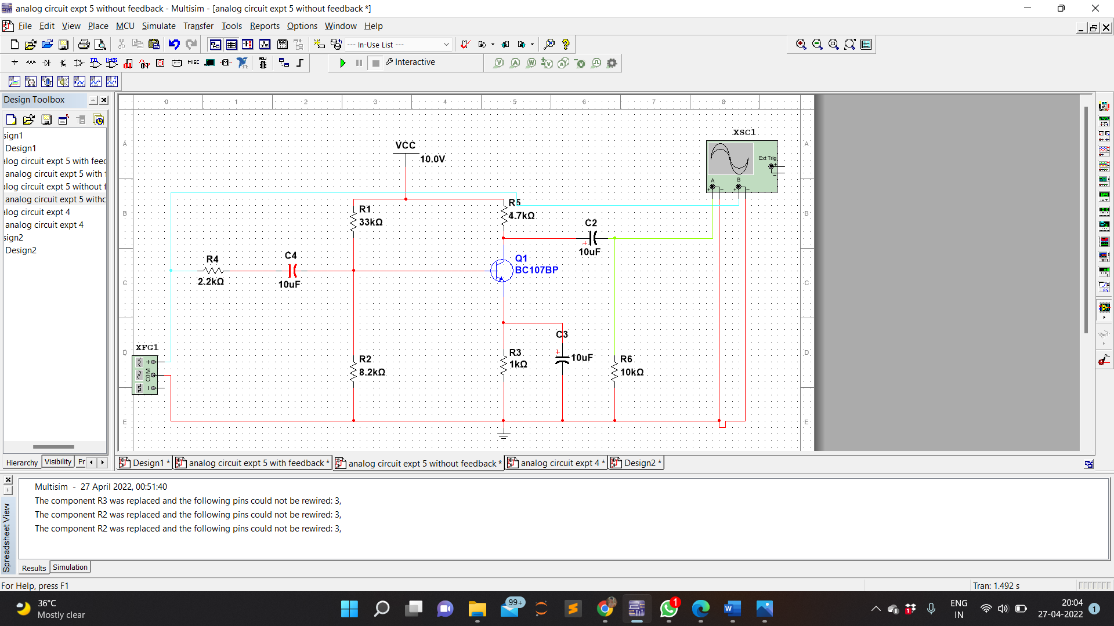

WAVEFORM IN CASE OF WITHOUT FEEDBACK

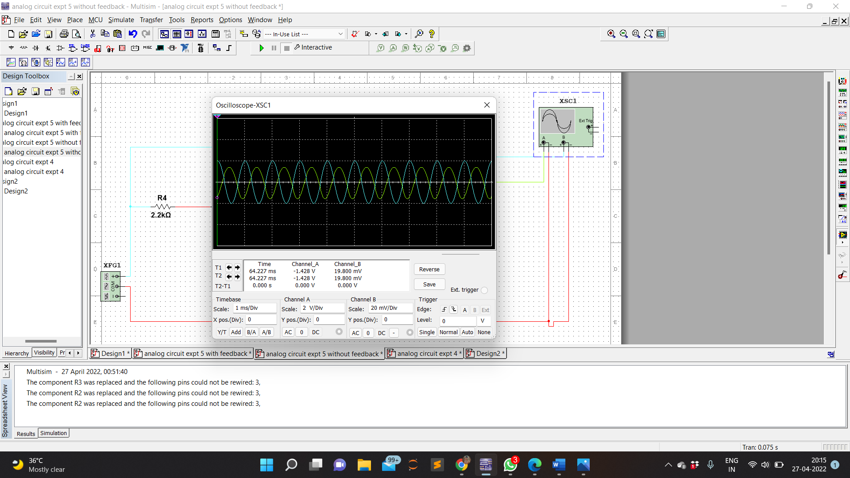

GAIN IN CASE OF WITH FEEDBACK

GAIN IN CASE OF WITHOUT FEEDBACK

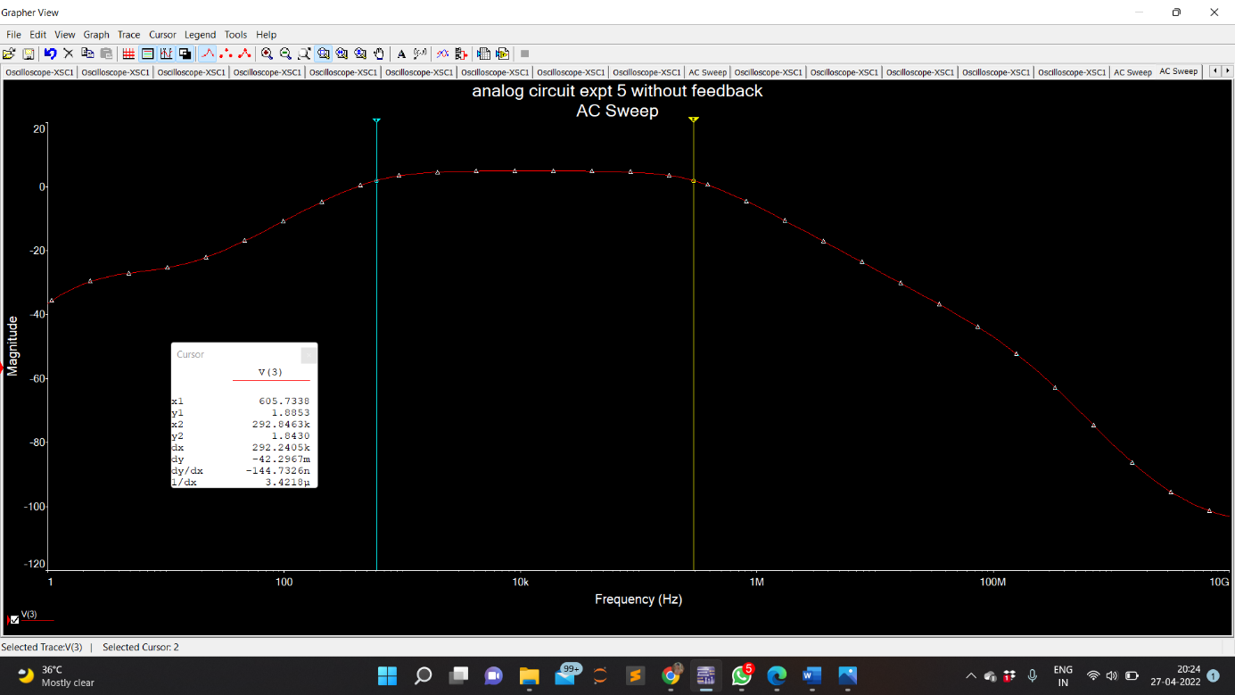

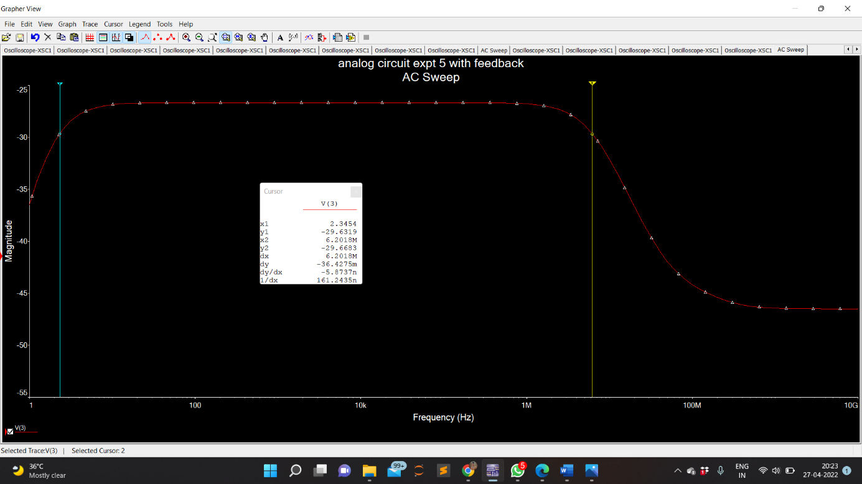

**WITHOUT FEEDBACK:**

Zin= Rs[Vin/Vs-Vin]

= 1000[2.246/20-2.246]

= 126.5

Zo= Rl[Vnl-Vl/Vl] = 1000[1.574-2.246] = -426.93

Av= Vl/Vin = 10.705/2.246 = 4.766

**WITH FEEDBACK:**

Zin= Rs[Vin/Vs-Vin]

= 1000[2.246/20-2.246] = 126.5

Zo= Rl[Vnl-Vl/Vl] = 1000[1-2.246] = -426.93

Av= Vl/Vin = 10.705/2.246 = 4.766

**PRECAUTIONS** :

* + 1. Avoid loose and wrong connections.
    2. Avoid parallax error while taking readings.

**RESULT**:

In this experiment we use BC107 transistor to design the circuit . Different graphs of gain and voltages were obtained using the CRO and the bode plotter .The different values of voltages were measured using the multimeter.